The receiver input DC3V or 5V (depending on the model you order), Mini size ,Learning button on the receiver to matching the transmitter, the low voltage relay is inward, the Super-heterodyne receiver module receiving sensitivity is high ,anti-interference performance is good . The receiver module is especially suitable with mobile phone lithium battery power supply, when the receiver input is DC4.2V the quiescent current is about 3.5mA, the relay actuation current is about 30mA.
The receiver is the learning code receiver, it can learn most fixed code and learning code transmitter with the same frequency, it can keep 16pcs different encoding code transmitter.
1. Working Voltage: DC3V/DC5V (do not put 5v into the 3v version)
2. Max Load: 2A ( DC24V 2A AC120V 2A )
3. Working Frequency: 433mhz
4. Frequency Deviation: more or less than 0.2MHz
5. Working temperature: -20'C- +80'C
6. Receiving Sensitivity: ≥-105dBm
7. Output State: the relay NO Junction output DC3V-5V high potential (HPOT) (Output +DC3-5V)
8. Modulation Mode: amplitude modulation (AM)
9: Size: 32mm×13mm×12mm (L×W×H) Mini Size
10. Output state: Momentary .Toggle. Latched adjusted by connecting with different dot (see diagram at base of this document – please allow time for it to display).
Momentary--------No Connection
Toggle--------Connect “T “& Mid Dot
Latched----------Connect “L” & Mid Dot
Momentary-------------Press the button is ON .Release your finger on the button is OFF
Toggle--------------- Press one button for one time is ON .press the same button again is OFF
Latched------------- Press one button is ON, press another button is OFF
Learning Method:
Keep on pressing the learning button for about 2 Seconds, the Learning LED indicator will flashing fast, then release your finger on the learning button ,the receiver have been entered into learning state .then press the transmitter transmit the signal ,the receiver indicator flashing fast again ,it
means that learning successfully.
Clearing the Code:
Keep on pressing the learning button about 6 Seconds, the receiver learning button LED indicator flashing from fast to slow, it means that clearing is successfully.

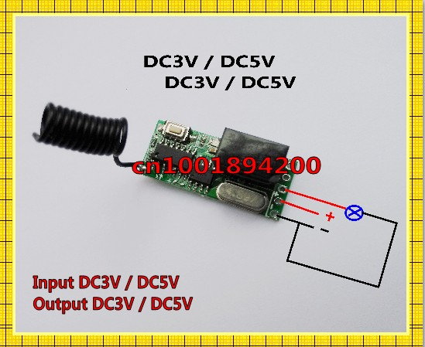
As standard these switches are supplied with 3/5v direct output (same as input), as shown in diagram above.

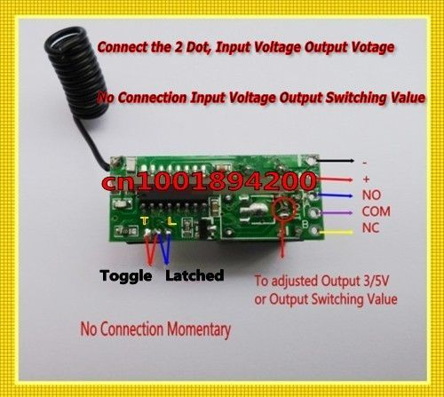

This can be changed to switching output (ie 0v at output–switch only acts as connector or disconnector of existing live applicance circuit). To change to switching output, remove the solder connection between the 2 points shown in the bottom of the circle in the diagram above.

