DC24V 1CH (Channel) Remote Control Switch

This DC24V Remote Control Switch is a multifunctional receiver board, with relay output switching value signal to switch electrical equipment on and off.
It is mainly used in Electrical operated gate, window, lifting appliances etc.
1. Working Voltage: DC24V
2. Working Current: 6mA or less
3. Working Temperature:-30'C- +70'C
4. Working Frequency: 315MHZ/433MHZ
5. Receiving Sensitivity:-105dbm
6. Control Load Voltage: AC/DC
7. Size: 50 x 34 x 17mm

Output State: Momentary Toggle Latched Adjusted by the Jumper on the Receiver

Momentary-----Take away Jumper or Jumper on any one pin

Toggle-----Jumper on Pin 1&2

Latched-----Jumper on Pin 2&3

Momentary-----Press the Button and Hold is ON, Release the Button is OFF. (1Relay Receiver with 1 Button Transmitter)

Toggle----Press the Button for 1 time is ON, Press the same Button again is OFF. (1Relay Receiver with 1 Button Transmitter)

Latched-----Press one Button is ON, Press another button is OFF. (1Relay Receiver with 1 Button Transmitter)

Learning Code: add Transmitter by the Learning Button on the Receiver.

How to add a transmitter
Input DC24V for the Receiver Board, when the LED Indicator ON Press the learning button on the board, it mean it enter the Learning State, Press any Button of the Transmitter
The LED Indicator will flash on which means it has been added sucessfully

How to clear the transmitter code
Input DC24V.Keeping press the Learning Button about 6s.the LED Indicator turn OFF, It mean clear successfully

It can keep 30pcs different code transmitter, if the codes are the same you can add as many as you like.
It can learn the same frequency fixed code and Learning Code transmitter.

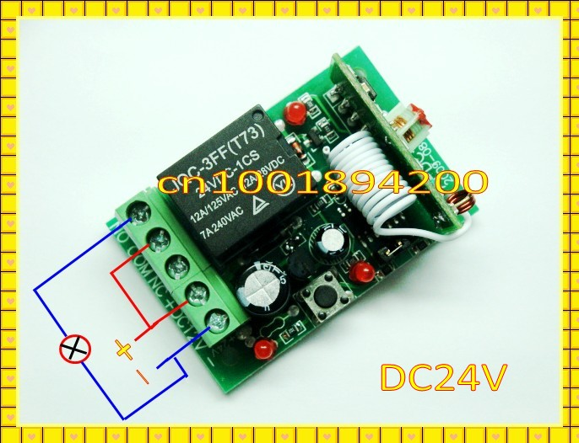
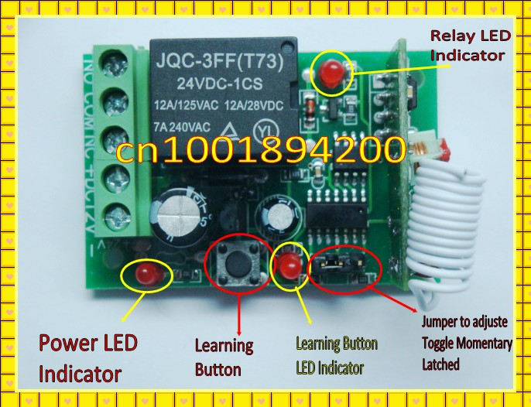
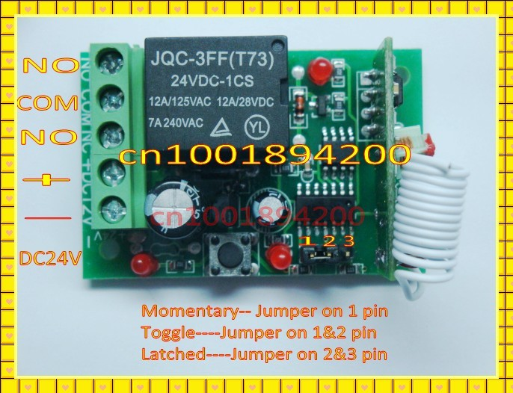

FAQs
Q Why is there no voltage output from the switch?
A There is no voltage output, the switch acts as a connecter or disconnecter for an existing live circuit.
Q Why is there no response from the switch when the remote is pressed?
A First try clearing the remote by holding down the learning button until the led light flashes, then add the remote again. If this doesn't work try changing the battery in the remote.
Q How do I extend the range?
A This is possible by ensuring there are no obstacles, the remote has a good battery and the receiver a good power supply. Also the receiver aerial can be gently extended.

